# **Sir Syed University of Engineering & Technology (SSUET)**

# **Software Engineering Department**

***Course Name: Artificial Intelligence (SE-314L)***

FRAUD DETECTION CODE

import pandas as pd

import matplotlib.pyplot as plt

import seaborn as sns

from sklearn.metrics import classification_report, accuracy_score

from sklearn.ensemble import IsolationForest

from sklearn.neighbors import LocalOutlierFactor

# Load the dataset using pandas

data = pd.read_csv(r'C:\Users\yagom\OneDrive\デスクトップ\AI PROJECT\creditcard.csv')  # Updated file path

# Dataset exploration

print(data.columns)

# Sample 10% of the dataset for quick processing

data = data.sample(frac=0.1, random_state=1)

print(data.shape)

print(data.describe())

# V1 - V28 are the results of PCA dimensionality reduction

# Plot histograms of each parameter

data.hist(figsize=(20, 20))

plt.show()

# Determine the number of fraud cases in the dataset

Fraud = data[data['Class'] == 1]

Valid = data[data['Class'] == 0]

outlier_fraction = len(Fraud) / float(len(Valid))

print(f"Outlier Fraction: {outlier_fraction}")

print(f"Fraud Cases: {len(Fraud)}")

print(f"Valid Transactions: {len(Valid)}")

# Correlation matrix

corrmat = data.corr()

plt.figure(figsize=(12, 9))

sns.heatmap(corrmat, vmax=.8, square=True)

plt.show()

# Prepare the data

columns = data.columns.tolist()

columns = [c for c in columns if c not in ["Class"]]  # Exclude the target column

target = "Class"

X = data[columns]

Y = data[target]

# Print shapes of the feature set and target

print(f"Feature set shape: {X.shape}")

print(f"Target shape: {Y.shape}")

# Define random states

state = 1

# Define outlier detection tools

classifiers = {

    "Isolation Forest": IsolationForest(max_samples=len(X),

                                        contamination=outlier_fraction,

                                        random_state=state),

    "Local Outlier Factor": LocalOutlierFactor(

        n_neighbors=20,

        contamination=outlier_fraction)

}

# Apply models and evaluate

plt.figure(figsize=(9, 7))

n_outliers = len(Fraud)

for clf_name, clf in classifiers.items():

    if clf_name == "Local Outlier Factor":

        y_pred = clf.fit_predict(X)

        scores_pred = clf.negative_outlier_factor_

    else:

        clf.fit(X)

        scores_pred = clf.decision_function(X)

        y_pred = clf.predict(X)

    # Reshape the prediction values: 0 for valid, 1 for fraud

    y_pred = [0 if pred == 1 else 1 for pred in y_pred]

    n_errors = (y_pred != Y).sum()

    # Run classification metrics

    print(f"{clf_name}: {n_errors} errors")

    print(f"Accuracy Score: {accuracy_score(Y, y_pred)}")

    print(f"Classification Report:\n{classification_report(Y, y_pred)}")

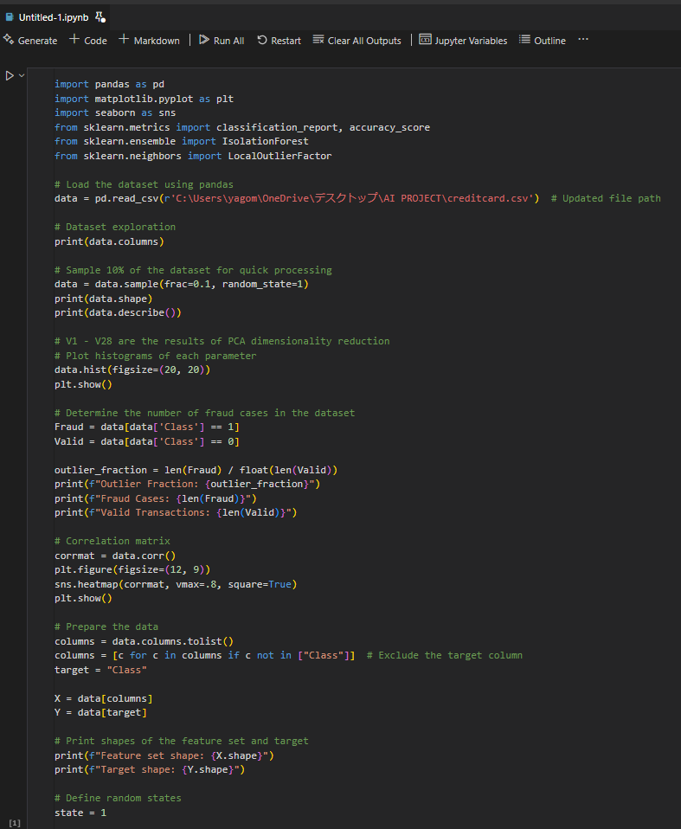

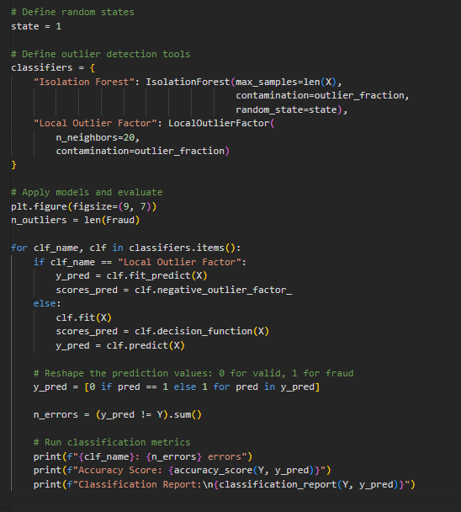

INDEX

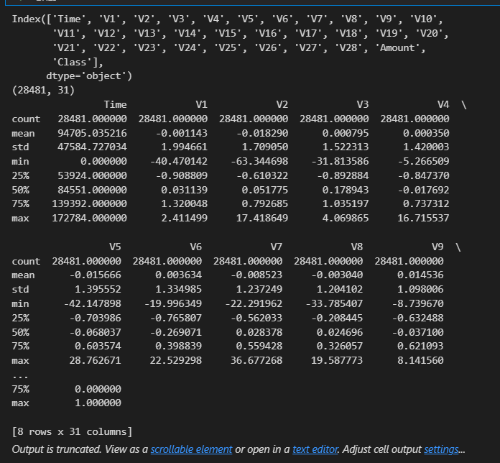

GRAPH

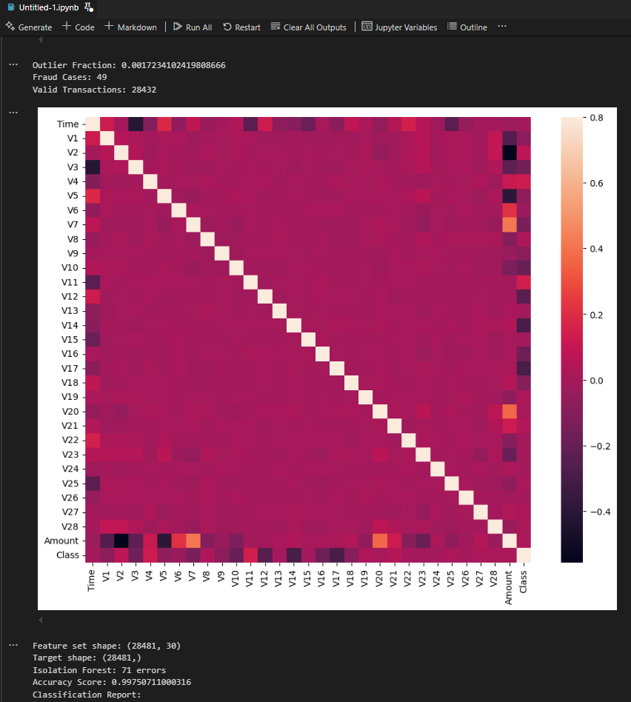

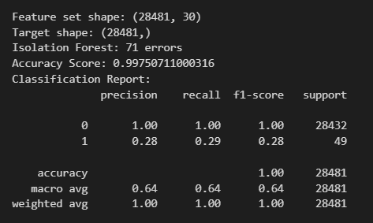

KNN ALGO

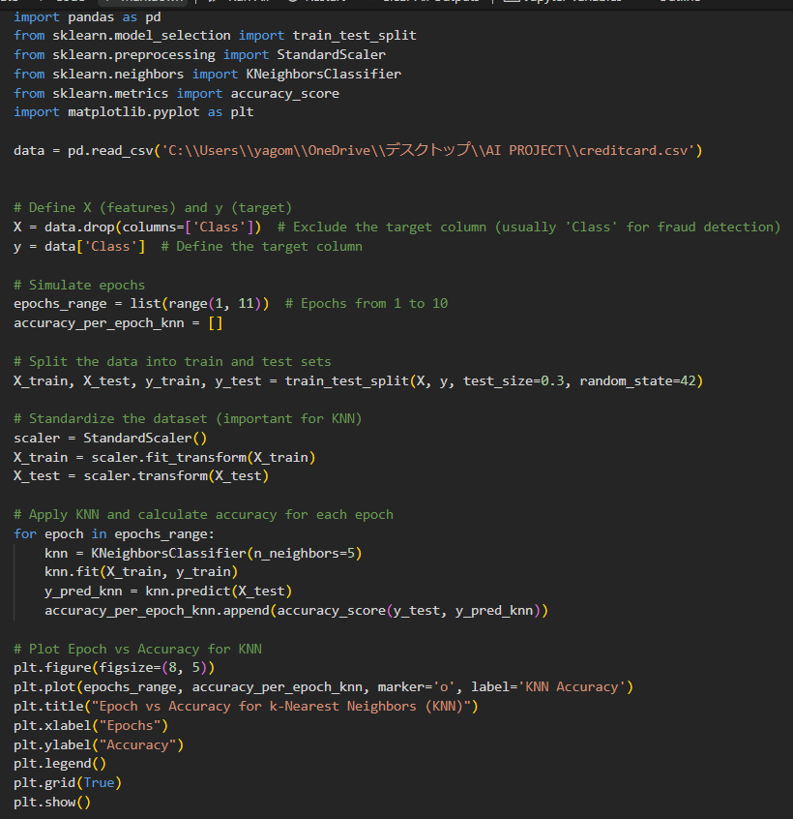

OUTPUT

NAÏVE BAYES

OUTPUT

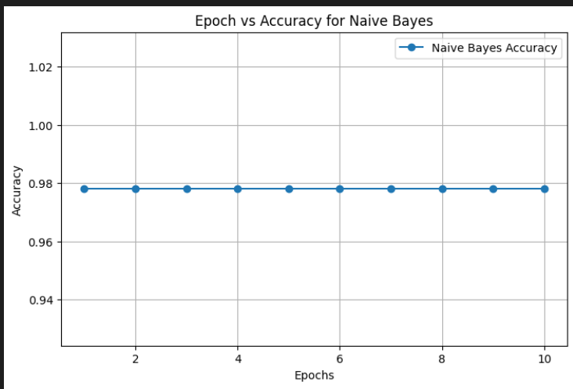

DECISION TREE

OUTPUT

LINEAR REGRESSION

OUTPUT

MULTI REGRESSION

OUTPUT

COMPARISON OF ALL ALGOS

OUTPUT

CONFUSION MATRIX AND CLASSIFICATION REPORT

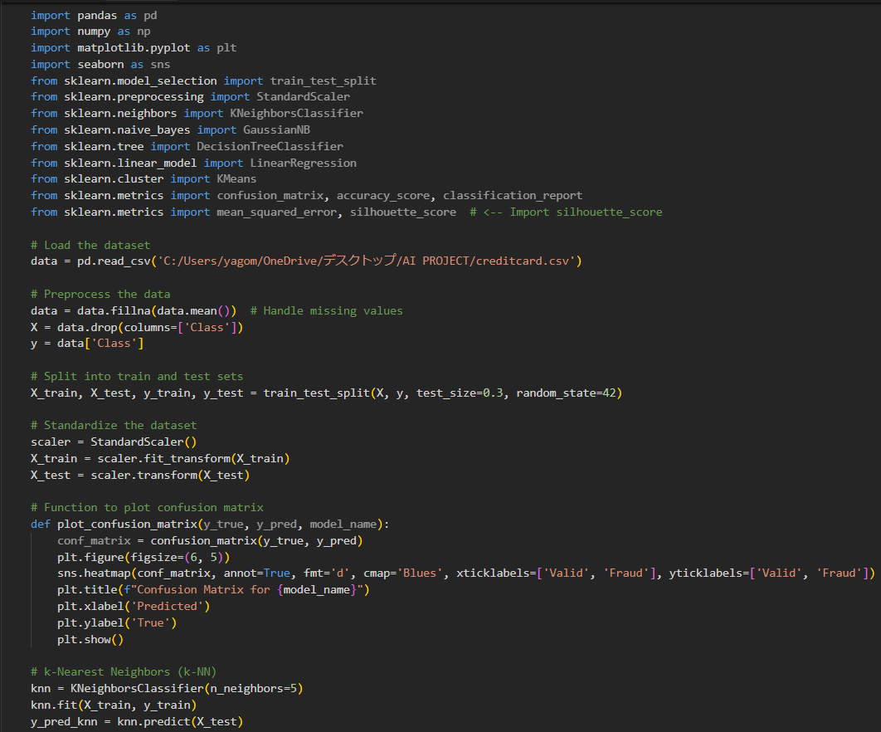

KNN ALGO

NAÏVE

DECISION TREE

LINEAR REGRESSION

MULTI LINEAR REGRESSION

K MEANS

